**Software Project Management Plan**

**Learning Management System**

02/19/19

**Team Members**

Dzung

Kevin

Thanh

Alejandro

Yerusalem

# Overview

## Purpose and Scope

A graphical user interface learning management system that will allow both students, professors, and administration for a university. It must be easy to use and meet the requirements that will satisfy all three groups. The system will contain basic information such as student’s name, student’s ID, registered courses in the current semester, the exam’s score in one course, GPA calculation. The system will allow professors to manage assignments and grades including being able to modify them. Admin of the system will be able to manage login information for both staff and students. The system will not fully comprise of all the necessity of a real system, but only contain what is essential for the project.

## Goals and Objectives

*The goal of the project is to create a learning management system must store and retrieve basic information such as student’s name, student’s ID, registered courses in the semester, each exam’s score in one course, GPA in the current semester.*

Project goals:

1. Establish a learning management system for university’s students and staff.
2. Create a graphic user interface system that meet the requirements.

Project objectives:

1. Create a database or a storage for keeping the information of students and staff.
2. Create an interface that will allow students to check their courses’ information, grades, and assignments. Professors should be allowed to update course information, change grades, and

## Assumptions and Constraints

**Assumptions:**

1. The IT team for the school will have infrastructure ready.
2. The IT team and management will have knowledge to implement the system.
3. Budget provided will be sufficient for any licensing or other fee.
4. Budget to include current LMS shutdown labor cost.
5. No other advanced features requested other than those that are stated.
6. Any specific 3rd party tool integration will be the responsibility of the school or IT team.

**Constraints:**

1. The LMS must be complete by 04/28/2018
2. GIThub must be used for implementation tracking.

## Schedule

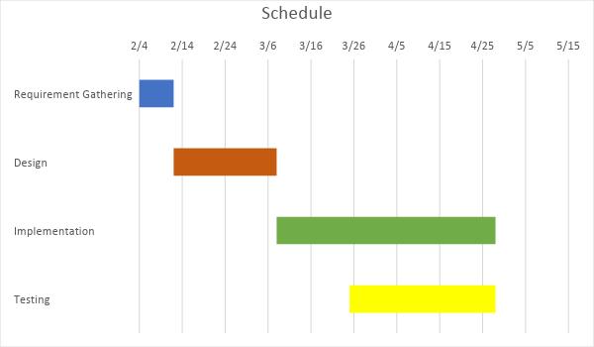

## Success Criteria

Success criteria spell out what has to happen before the project can be considered a success. Having explicit success criteria serve two purposes. First, during a project success criteria help to focus attention on what is important. Second, at the conclusion of a project (project closure) success criteria are used to assess whether or not the goals and objectives of the project have been achieved.

To be effective in both of these endeavors, success criteria must be defined in a way that is both quantifiable and verifiable.

For more advise on how to define the success criteria for a project, I recommend: *Success Criteria Breed Success*, by Karl Wiegers. It is available on the web.

*Partial Example*

* Total project cost does not exceed 20% of the post-requirements phase estimate.
* All high-priority use cases in the requirements specification are delivered before May 15.

## Definitions

**GIT -** a free and open source distributed version control system designed to handle everything from small to large projects with speed and efficiency.

**GITHUB -**  a web-based hosting service for version control using Git.

**GUI -**  Graphical User Interface.

**LMS -** Learning Management System.

## Evolution of the Project Plan

This section describes plans for updating the project plan throughout the project.

*Partial Example*

Before the start of an iteration, the project plan will be updated to include a schedule of detailed tasks for the upcoming iteration. At the conclusion of an iteration, the project plan will be updated to include the actual effort for each completed task.

Risk mitigation efforts will be evaluated at the start of each iteration. Severe risks will be analyzed and added to the project plan as soon as they materialize.

# Startup Plan

## Team Organization

This section explains project roles and the authorities and responsibilities associated with these roles. Lines of communication, authority and reporting relationships are often shown with an org chart. If development team is known, actual names can be associated with roles.

*Partial Example*

Project Manager: The project manager is responsible for creating the project plan (with input from those doing the work), managing risks, running the weekly team meeting and providing monthly status reports to senior management.

Programmers (3): Programmers are primary responsible for coding and unit testing modules. They are also expected to take part in architecture planning and review meetings.

Build Coordinator: The build coordinator is responsible for setting up, running and distributing the results of the nightly build.

## Technical Process

This section describes the software development methodology or conventions the team agrees to live by. When following an organization standard process, this section will refer to the standard process and state any deviations that are planned for this project. In the absence of an organization standard process, this section will define planned phases, entry and exit criteria for each phase, major milestones, workflows, and other aspects of the proposed development process.

## Tools

* Programming Language – Python 3
* Version Control – source code and written artifacts will be stored on to the github repository
* Build tools – Visual studio 2017

# Work Plan

## Activities and Tasks

A work breakdown structure is an excellent tool for identifying a complete list of tasks.

Depending on the needs of the project, some or all of the following attributes will be recorded for each task:

* Task name
* Task Description
* Owner
* Effort estimate
* Actual effort
* Planned start and stop dates
* Actual start and stop dates
* Dependencies among other tasks

## Iteration Plans

An iteration plan is a short-term fine-grained plan that shows the tasks to be completed during an iteration.

# Control Plan

## Monitoring and Control

Include in this section plans and procedures for tracking progress and controlling performance. Included here will be the approximate dates of technical as well as managerial reviews. Typically each major milestone or project phase will end in a review.

For projects that don’t have a separate communication plan, this section may also include information on the timing and content of status reports and other project review documentation.

*Partial Example*

Weekly – Team meeting. Project participants report status, progress and potential problems.

3/1/2008 – Critical Design Review. Formal inspection of product architecture.

5/15/2008 – Executive Review. The project manager presents current project status to project sponsor and senior executives.